Siddharth Vaghasia & Mayuresh Joshi

[Email address]

Abstract

This document provides step by step instructions on how to import the PowerApps and setup the SharePoint site for using the covid 19 vaccination survey app

Covid 19 Vaccination Survey App

PowerApps & SharePoint setup guide

Contents

Brief about Application 2

Step 1: Importing lists into SharePoint using PnP PowerShell 2

Step 2: Import the PowerApps 2

Step 3: Configure the survey configuration list 10

Step 4: Sharing the app link with the users 10

# Brief about Application

* As with current situation on Covid, it is important to get ourselves vaccinated. All the countries governments are running vaccination drive.
* As an organization, it become important to get survey of employees about this vaccination status.
* This PowerApps and SharePoint based application can be used to get the vaccination status of all the employees in organization.
* Using the app, employee of the organization can provide information about their current vaccination status like if they have been vaccinated, have they taken both doses and which vaccine drive.
* This survey data will give organization to how many employees have been vaccinated and other information related to vaccination.
* Employee (normal user) can come to this app and update the data anytime until they fill out their information till dose 2.
* HR/Admins(configurable) can view dashboard to see different charts based on total survey filled by employees, total vaccinated, employees taken first dose or second and which vaccine brand.

# Step 1: Importing lists into SharePoint using PnP PowerShell

To use this survey PowerApps, you need to have below two lists available on your SharePoint site.

1. Covid19Survey – This is main list where the submitted surveys/forms data will be stored
2. Covid19SurveyConfiguration - This is configuration list to setup HR/Admin email address for whom we need to enable dashboard app. This is so that the feature is not visible to everyone in company but only few limited peoples which we can set.

We have provided you the PnP exported list templates. You can easily import these list templates by running below powershell:  
  
# install the PnP powershell

#Install-Module -Name PnP.PowerShell

$DestSiteUrl = Read-Host -Prompt 'Please enter SharePoint URL'

$ListPath = Read-Host -Prompt 'Please provide full path to Lists XML file'

#1 - Connect to the destination SharePoint site

Connect-PnPOnline -Url $DestSiteUrl -UseWebLogin

#2 - Import the items from the template file

Invoke-PnPSiteTemplate -Path $ListPath

this PowerShell is also attached with this project.

# Step 2: Import the PowerApps

Login to your powerapps environment, and click on import canvas apps as shown below:

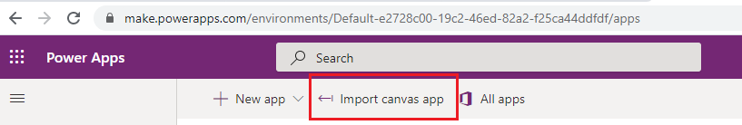

Select the zip file for the survey app from your local machine and click on import

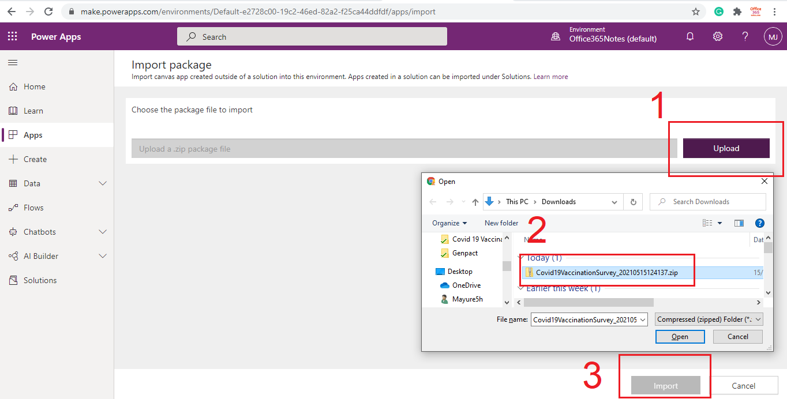

When you import it, make sure that the Import setup is “Create as new” as shown below:

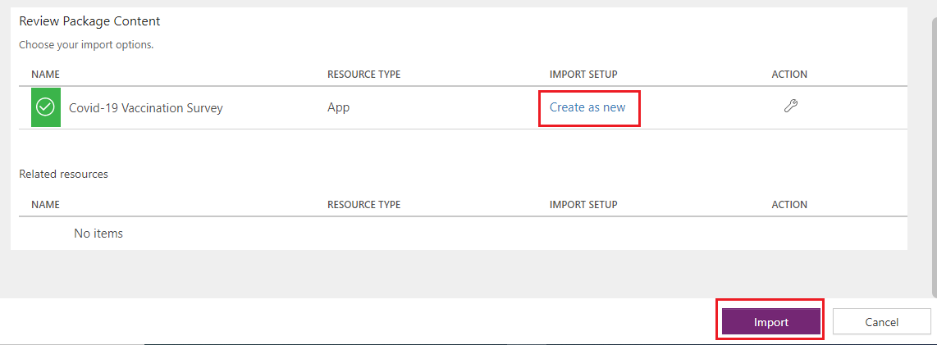

Once the package is successfully imported, you will see the below message on the same page.

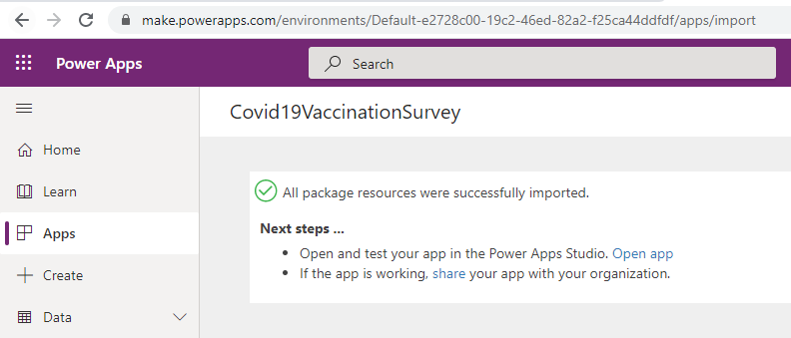

Click on Apps from left navigation and you should be able to see the newly imported app as shown below:

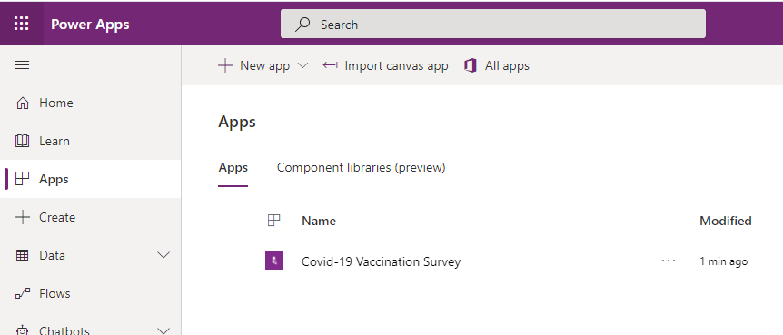

Click on Edit the app

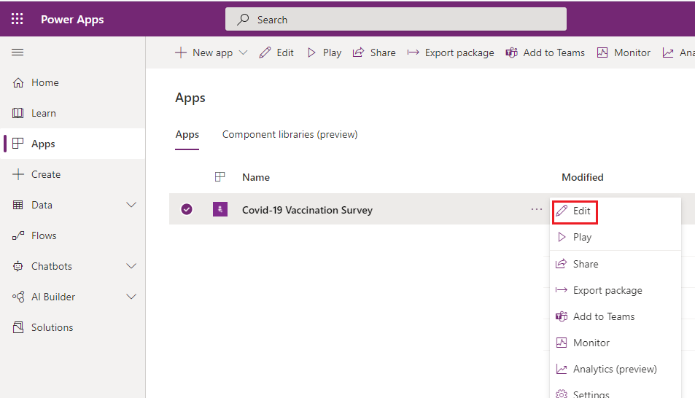

We need to replace the SharePoint list datasources that we imported earlier. To do so, just remove both the data sources and add again as shown below:

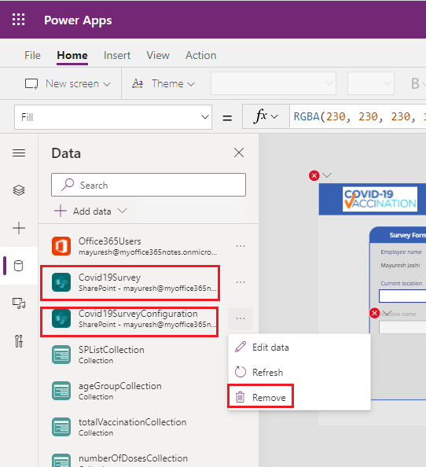

Add the data source by selecting SharePoint and enter the site url where you have imported the lists:

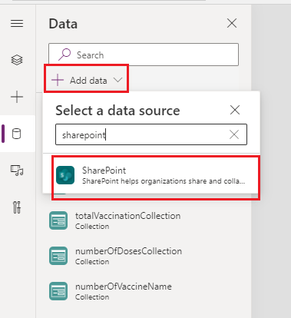

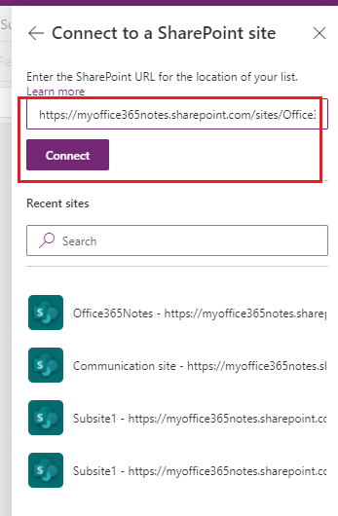

Select both the lists and click on Connect:

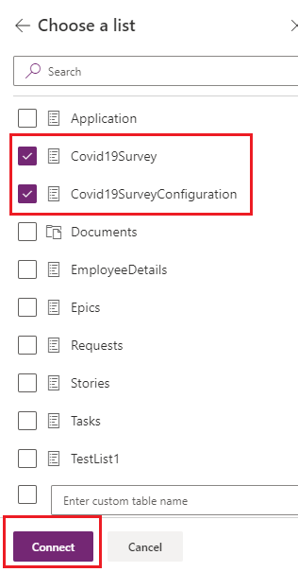

Then click on File menu and Save and Publish the app.

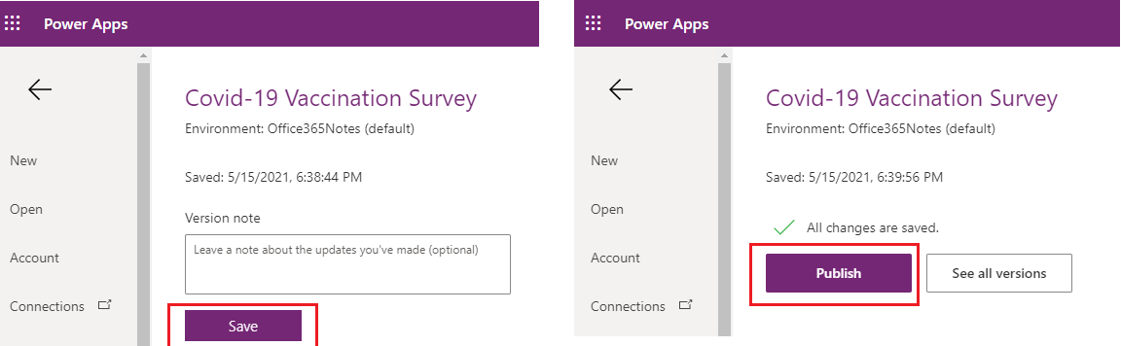

# Step 3: Configure the survey configuration list

Open the Covid19SurveyConfiguration list from Site contents.

Add two entries as shown below.

1. **ManagerEmails**: Enter emails of all Survey Managers (separated by comma or semicolon), so that they can see the dashboard tab on the app to see the survey results.
2. **ShowDashboardToAll(Y/N)** : Enter Y or N in this item value. This will enable/disable the Dashboard tab for all users.

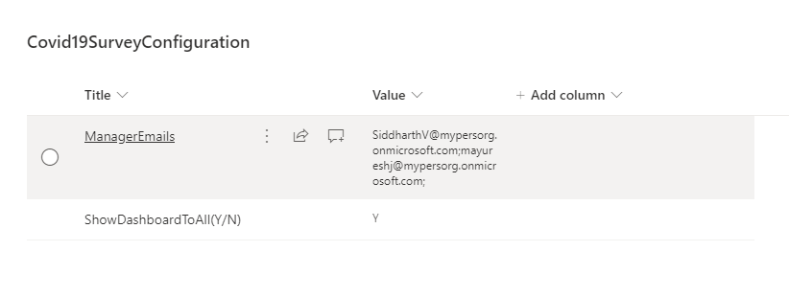

# Step 4: Sharing the app link with the users

To share the app link with the users so that they can submit the survey, go to powerapps portal and click on app details as shown below

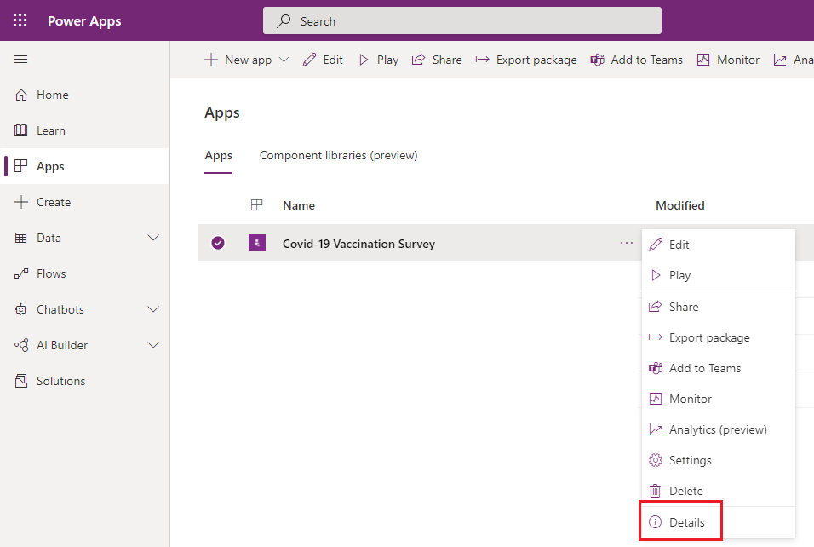

Here you can find the shareable link with the users:

